# CSS Layout - Flexbox

Problems for exercises and homework for the ["HTML and CSS" course @ SoftUni](https://softuni.bg/courses/html-and-css). Submit your solutions in the SoftUni Judge system at <https://judge.softuni.org/Contests/4382/04-CSS-Layout-Flexbox>.

## Property: Display Flex

Use the skeleton is in resources to achieve the following view:

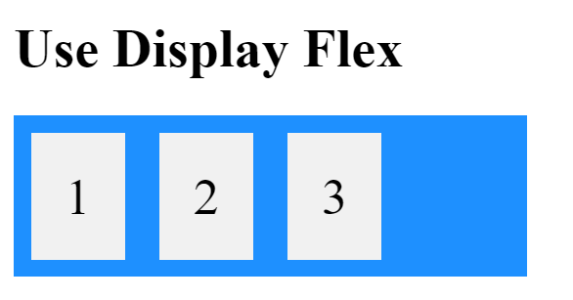

Use **display** to solve the problem.

## Property: Flex Direction

Use the skeleton is in resources to achieve the following view:

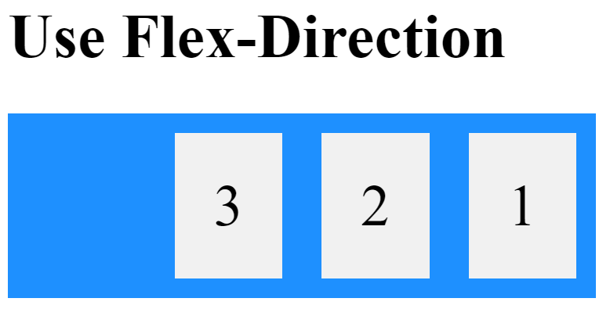

Set **flex-direction** to **row-reverse** to solve the problem.

## Property: Flex Wrap

Use the skeleton is in resources to achieve the following view: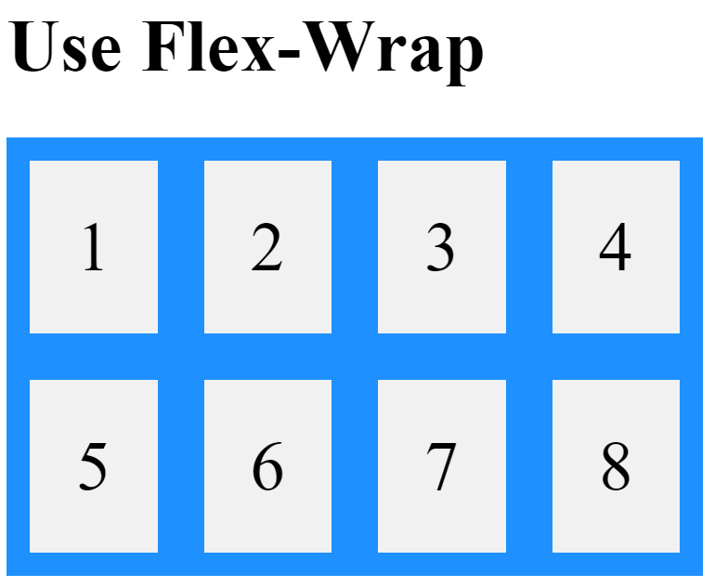

Set **flex-wrap** to **wrap** to solve the problem.

## Property: Justify Content

Use the skeleton is in resources to achieve the following view: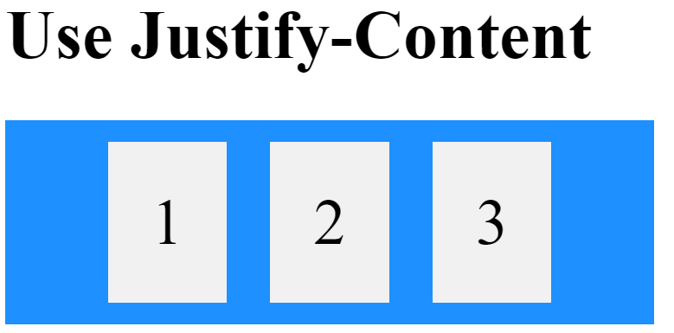

Set **justify-content** to **center** to solve the problem.

## Property: Align Items

Use the skeleton is in resources to achieve the following view: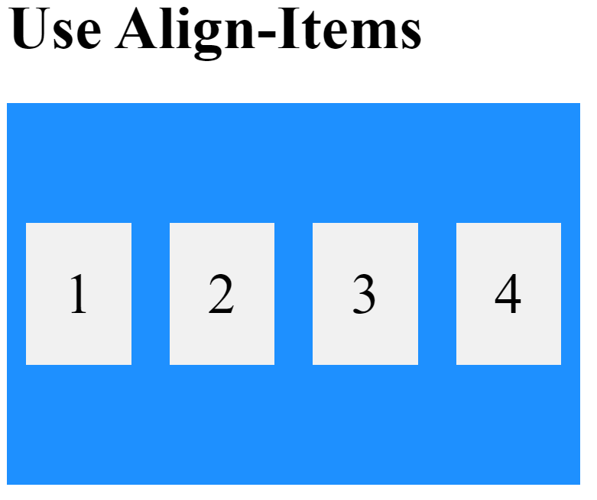

Set **align-item** to **center** to solve the problem.

## Property: Align Content

Use the skeleton is in resources to achieve the following view: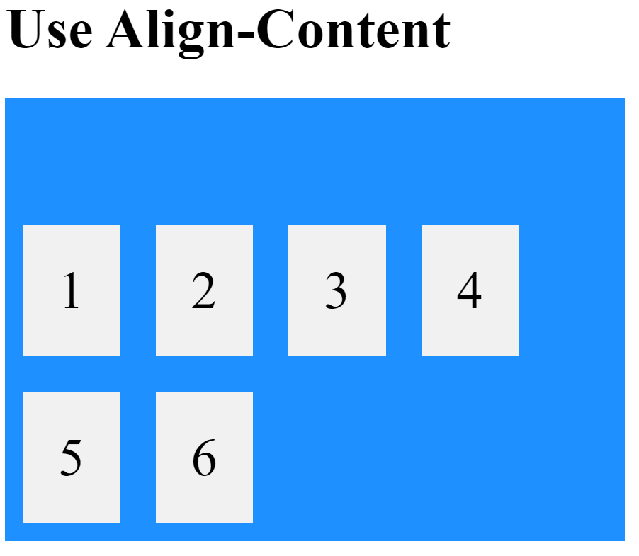

Set **align-content** to **flex-end** to solve the problem.

## Property: Gap

Use the skeleton is in resources to achieve the following view: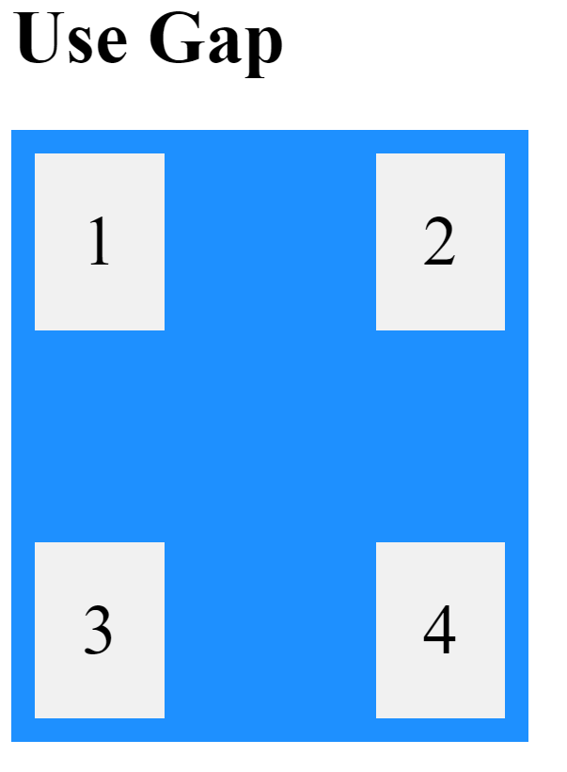

Set **gap** to **70px** to solve the problem.

## Property: Flex Grow

Use the skeleton is in resources to achieve the following view: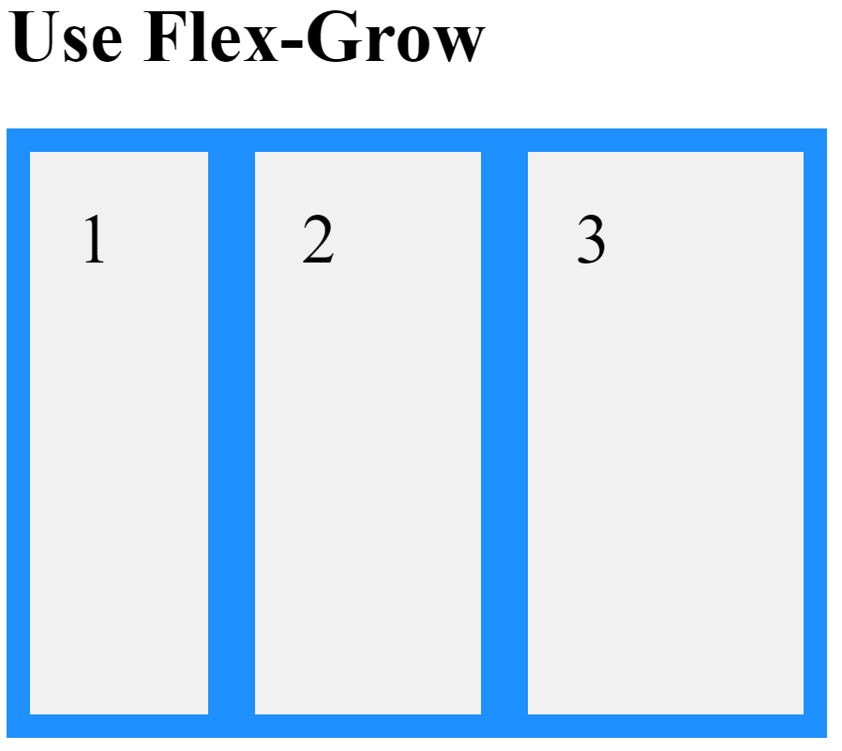

Use **flex-grow** to solve the problem:

* **Box One – 1**
* **Box Two – 2**
* **Box Three – 3**

## Property: Flex Shrink

Use the skeleton is in resources to achieve the following view:

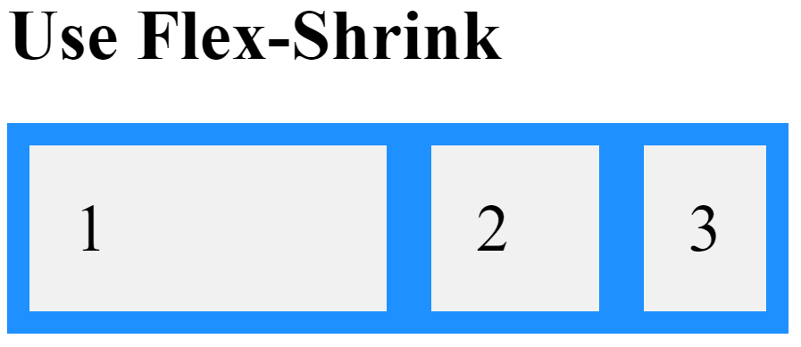

Use **flex-shrink** to solve the problem:

* **Box One – 0**
* **Box Two – 1**
* **Box Three – 2**

## Property: Flex Basis

Use the skeleton is in resources to achieve the following view: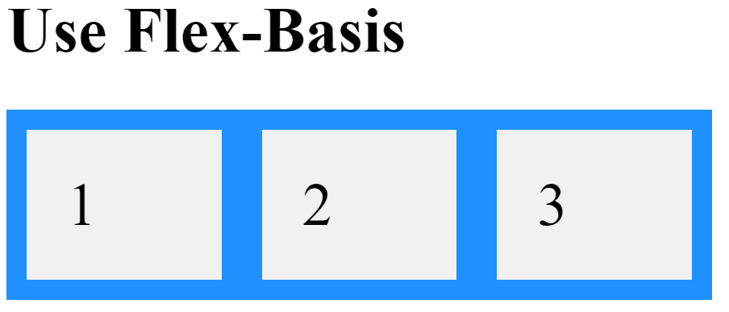

Set **flex-basis** to **120px** to solve the problem.

## Property: Align Self

Use the skeleton is in resources to achieve the following view: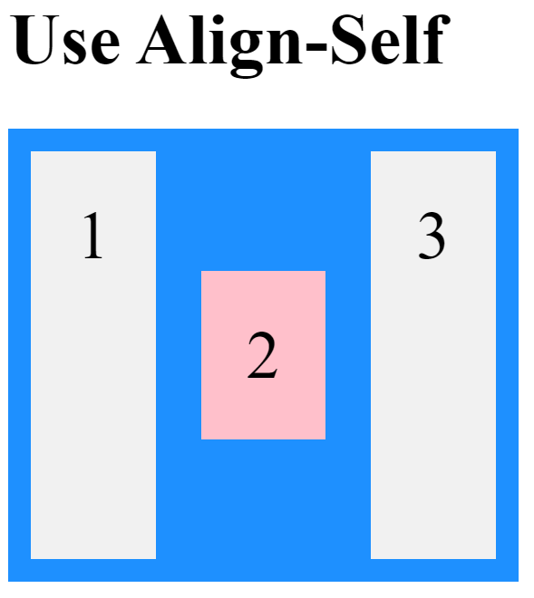

Set **align-self** to **center** to solve the problem.

## Property: Order

Use the skeleton is in resources to achieve the following view: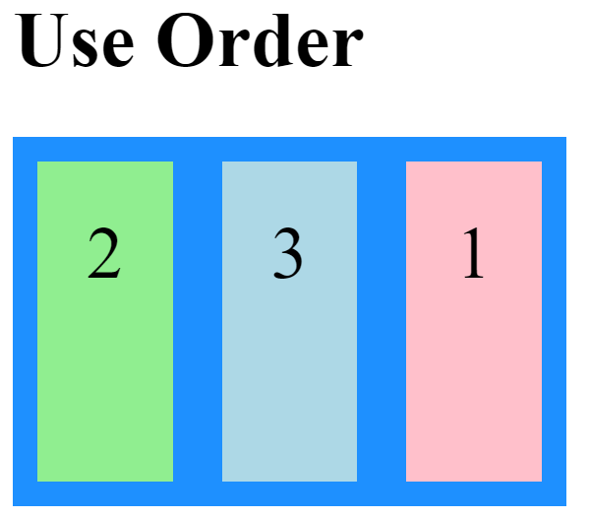

Use **order** to solve the problem:

* **Box One – 2**
* **Box Two – 0**
* **Box Three – 1**